1.create the master instance and the slave instrance.

Download java,git,maven,tomcat and jenkins on master.

Download java,git and tomcat on slave machine

Go to jenkins interface and add maven tools on it. Establish the SSH connection of master with the slave using node.

Create the job

Select the custom workspace /mnt/project for the git repo to clone.

The restrict the job to run on the master machine.

And the script to execute the job.

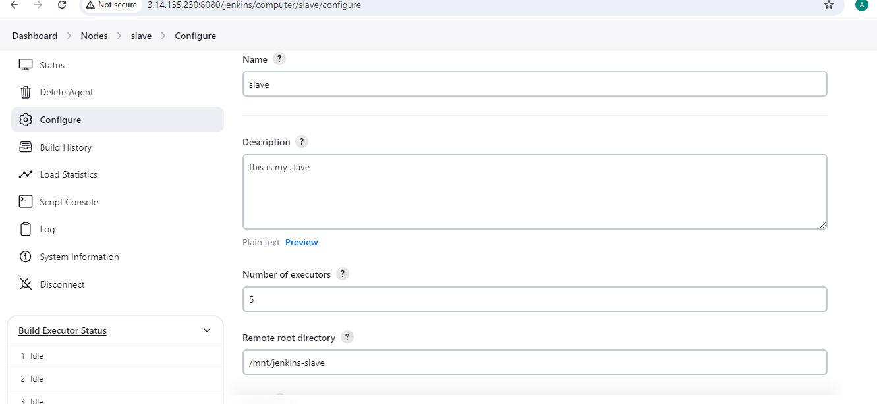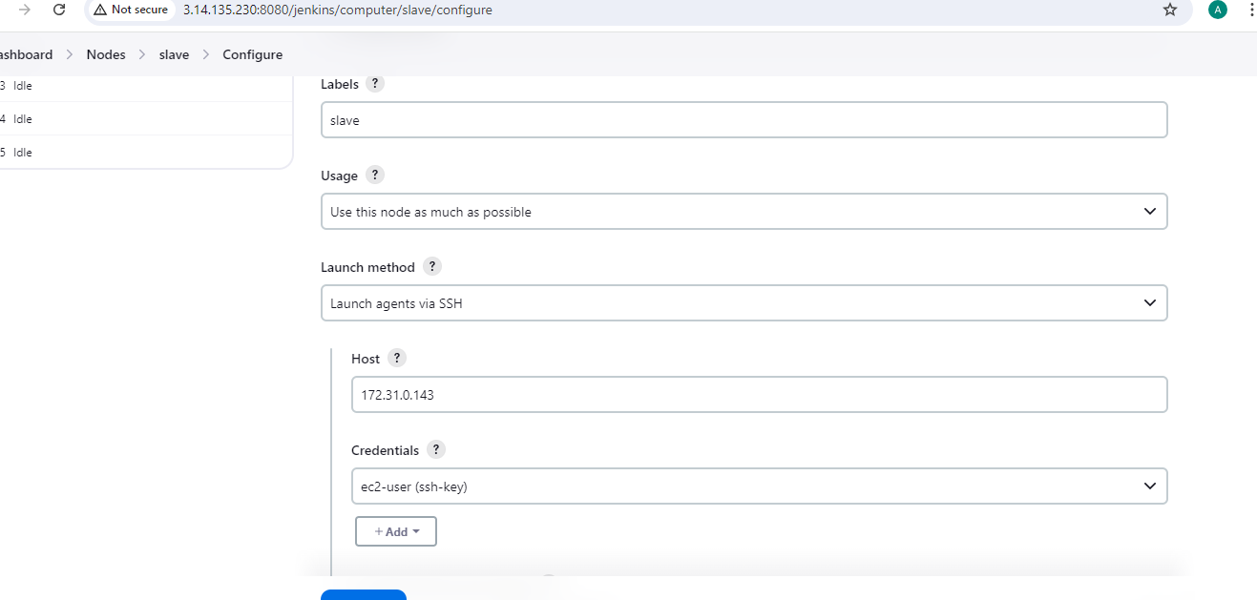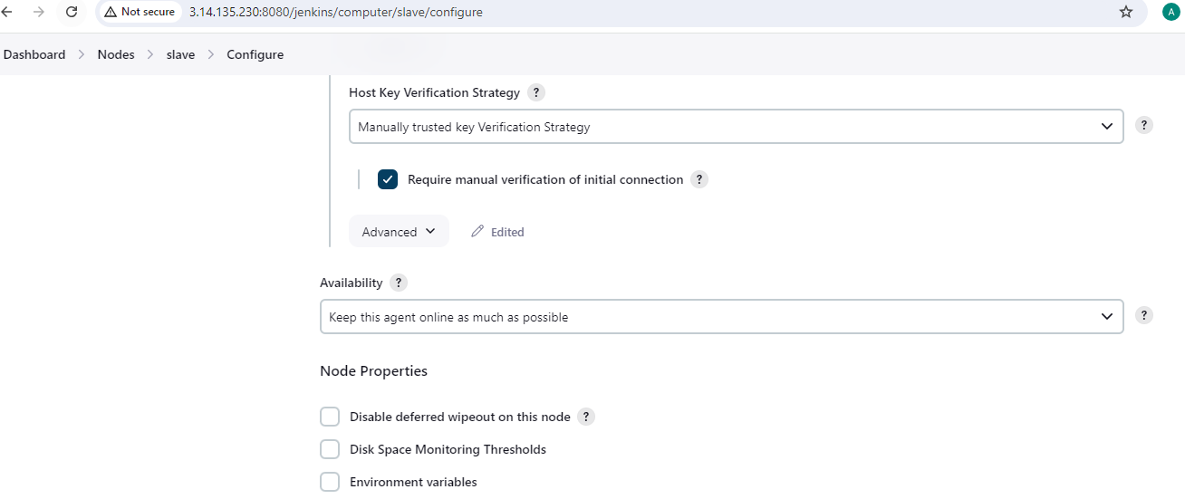The job is created to run the war file over the internet through tomcat present on the slave machine.

